**Catalyst PON Series by Cisco**

The Cisco PON switch industry's newest contribution is the PON Series. When it comes to switches and hubs, there is a common misconception that they are one and the same. This is not the case. There are various distinctions between the two, including:

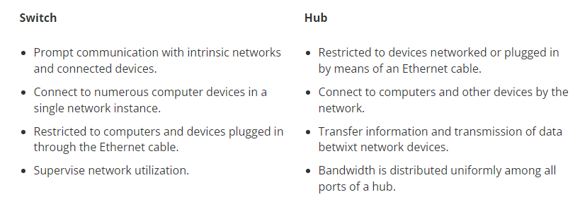

When it comes to starting a business, a business network is one of the most critical factors to consider. All of the distinctions necessary in a network in terms of speed and settings are made by having a comprehensive awareness of the numerous differences between the kinds of switches in a networking grid. An Ethernet switch's most basic and primary function is to create a local area network (LAN) of networked computers or networking devices. This was the necessity and understanding a few years ago; now, it is considered that adding various types of switches can provide an organisation with better control over their data, computers and devices, routers, hubs, access points, and other devices.

Network switches are essential for any business that wants to run smoothly. A network switch is essential for efficient operation of an organization. It is a basic component element that links many computers and other networking devices. Switches allow devices to share, distribute and transmit data, which facilitates communication among connected devices. The switches work by processing data packets, and then course-plotting them to designated destinations. A network switch, which can connect devices like computers, printers and servers in a large business, can be used to transfer data among all interconnected gears.

There are many network switches, and there are many manufacturers. Cisco is one of the most prominent organizations in this industry. Cisco offers a range of networking devices and switches that provide top-quality services and high data protection. The smart world requires smart technology. Cisco is able to understand the business needs and offer the right products. Cisco Catalyst's PON Series provides:

* **Security:** With AI and ML-powered anomaly recognition, including zero-trust accessibility secures users and connected devices at data transmission rate speed.
* **Automation:** For businesses and individuals alike, AI-powered and analytical data makes IT operations and functions dynamic, pliable, and simple.
* **Connection:** Wi-Fi 6 and Cisco Multi-gigabit Technology were combined to provide a wired and wireless foundation that provided dependable, optimised, and augmented connectivity.

PON stands for Passive Optical Network and has unquestionably been around for a long time. It was created at the start of the 1990s to address a serious network problem involving cellular network service providers. Surprisingly, the PON's difficulty revolves around call hold times and the start of the general Internet.

PON was thought to have the ability to provide traditional residential services as well as the annoying issue of bypassing the access to the broadband Internet connection straight to the Internet service provider because it was essentially designed for and for some situations partially by Cellular Service Providers. They are referred to as triple-play services by technical personnel (audio, data, and video). The proposed solution must address two critical deployment customer pain points:

* Warped pair copper-based electric wirings have a 100-meter remoteness constraint.
* The challenge, combined with the need for power, necessitated the employment of amplifiers to connect the headquarters to the end-user.

GPON has gained support in enterprise-level networks such as seven-star hotels, spas, resorts, educational institutions, metro stations, high-rise residential and office buildings, armed forces, and healthcare amenities, despite the fact that Cisco Catalyst PON was originally intended and designed for service providers and FTTx deployments and arrangements. The reason for this is that they use many of the same networking infrastructure and distributed access requirements for consumer housing services, such as:

* Services that are triple-play (data, audio, and video).
* Long-range space between the central internet hub and Ethernet end-point customers should be accommodated and adjusted.
* Ethernet docks with a high density of Gigabit bandwidth.
* Fibre Optics Services

Copper and dynamic fiber-based Ethernet apportionment networking has evolved to be the enterprise nexus regional topology of company type choice, with optimal bandwidth competence, end-to-end visibility, throughput, and be in command of point-to-point connection. Corporate-level GPON is a decorative choice to see as a wonderful fit for business for firms that have already chosen the PON topology or are expected to supply Gigabit high-speed and triple-play services in a "philanthropic enterprises" setting. More Cisco series can be found on [our website](https://subserve.co.uk/).